**Comsats University Islamabad**

**Compiler Construction**

**Kulsoom Khurshid (SP20-BCS-044)**

**Hammad Tufail (SP20-BCS-028)**

**LAB 2**

**Lab Task**

Task 1:

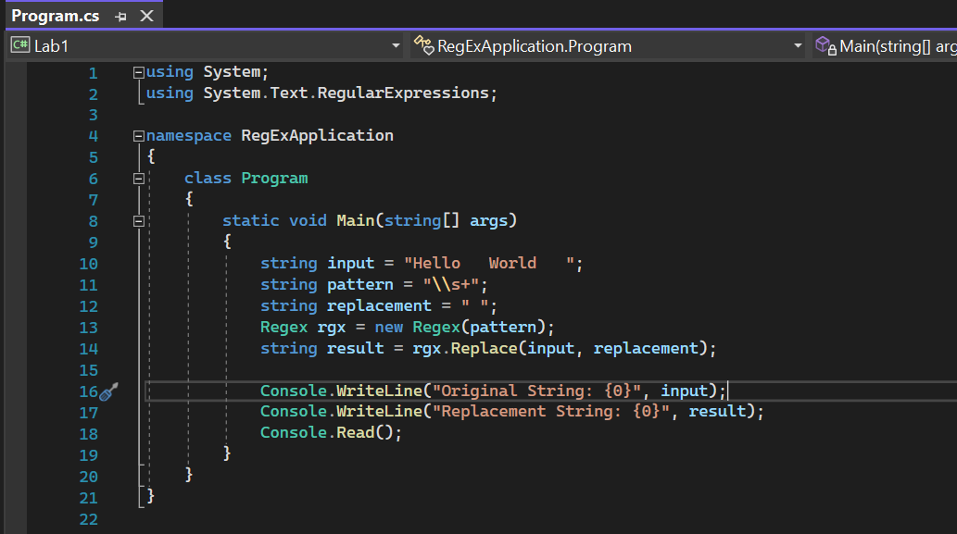

Output

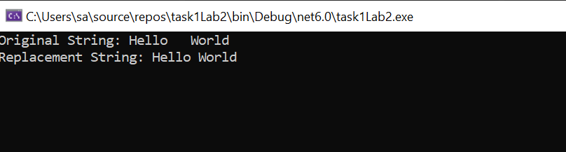

Task 2:

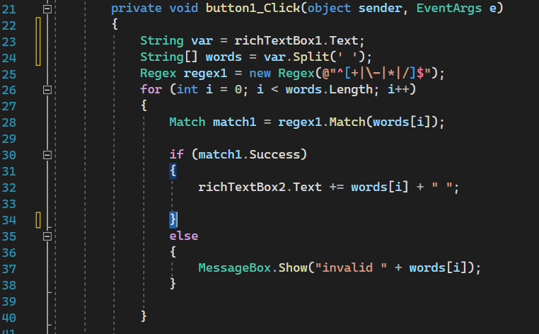

Output

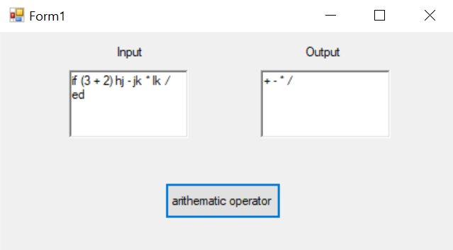

Task 3:

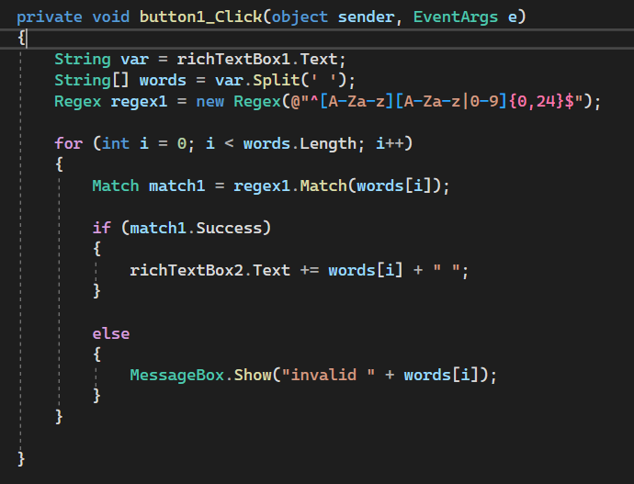

Output

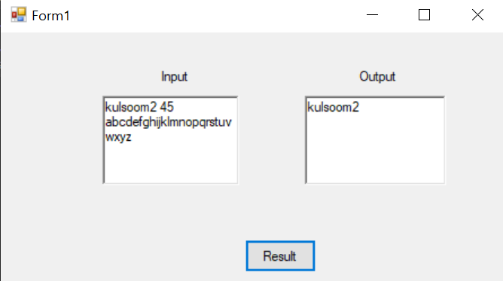

**Graded Task**

Logical Operators:

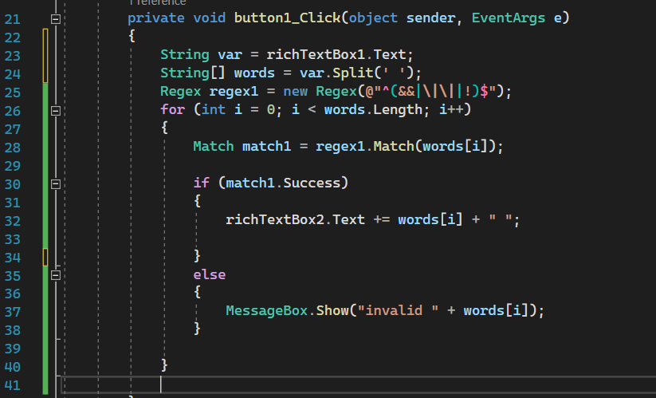

Output

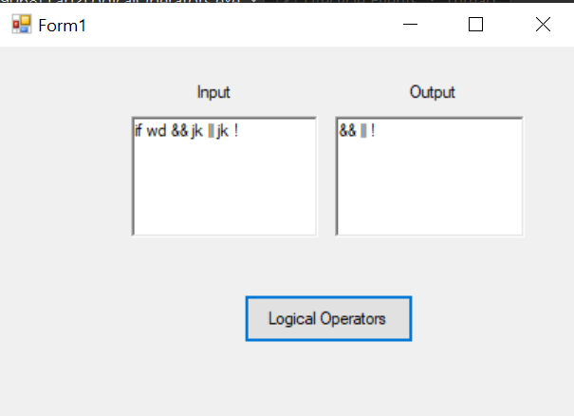

Relational Operators:

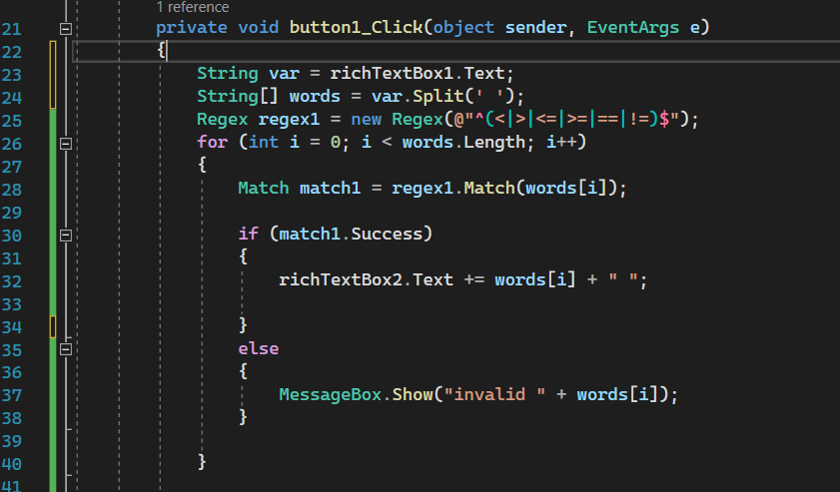

Output

